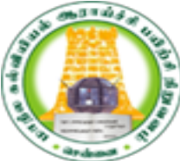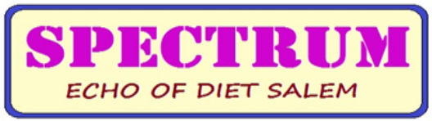

DISTRICT INSTITUTE OF EDUCATION AND TRAINING
UTHAMACHOLAPURAM, SALEM-636 010
April-September 2020 PREPARED BY: PSTE BRANCH Vol. 3 : No.: 8

Since the COVID -19 pandemic has disturbed the normal lifestyle of people across the globe, the inclusion of technology and creating virtual world has come to the rescue. Amongst many educational institutions, schools have also shifted their base to virtual platforms to conduct classes online. Consequently, catering to the needs of all stages of education from pre-primary to university level, online education has emerged as an alternative to ordinary face to face classes. According to the Government of Tamil Nadu many initiatives have been taken to overcome the issues in students learning from pre-primary to higher secondary level. DIET, Uthamacholapuram, Salem faculties have also shifted their base to virtual platforms and they have contributed their knowledge through many virtual programs i.e., e-module preparation, conducting webinar etc.,
Development of the e-module
The Bridge Course Module is prepared to fulfil the gap in the learning of lower grade to higher. DIET, Uthamacholapuram has prepared Bridge Course Module for Class V in Tamil, English, Mathematics, Science and Social Science. The topics and sub-topics have been identified as need to be reoriented to the students for each subjects, based on the difficulty level and significant of the topics, the digital lesson plan has been prepared by the faculty members in DIET.
Bridge Course Videos Preparation
As per the guidance given by State Council of Educational Research and Training, the Bridge Course Module has been prepared as digital video lessons. The teachers presented the content in interesting way by providing real life illustrations and portrait of the content for better comprehension. 10 video lessons for each subjects was prepared, so the total number of videos are 50 altogether.
The list of faculty members who involved in the preparation of e-module and script for video lesson preparations are listed below.
Sl no | Subject | Faculty members
1 | Tamil | M.JAYAMANI, Lecturer
2 | Tamil | K.KALAIVANAN, Lecturer
3 | English | B.ANANTHI, Lecturer
4 | English | S.SELVI, Lecturer
5 | Mathematics | M.MAHALAKSHMI, Lecturer
6 | Mathematics | R.KAVITHA, Lecturer
7 | Science | S.MANIKANDAN, Lecturer
8 | Science | C.ANBARASAN, Lecturer
9 | Social science | G.DHANAMMAL, Lecturer
10 | Social science | R.RAVI, Lecturer
Bridge course videos were telecasted on TN Kalvi TV, and it was utilized to learn the content presented in the video by the students. The videos have reached the target learners and ensured the learning.
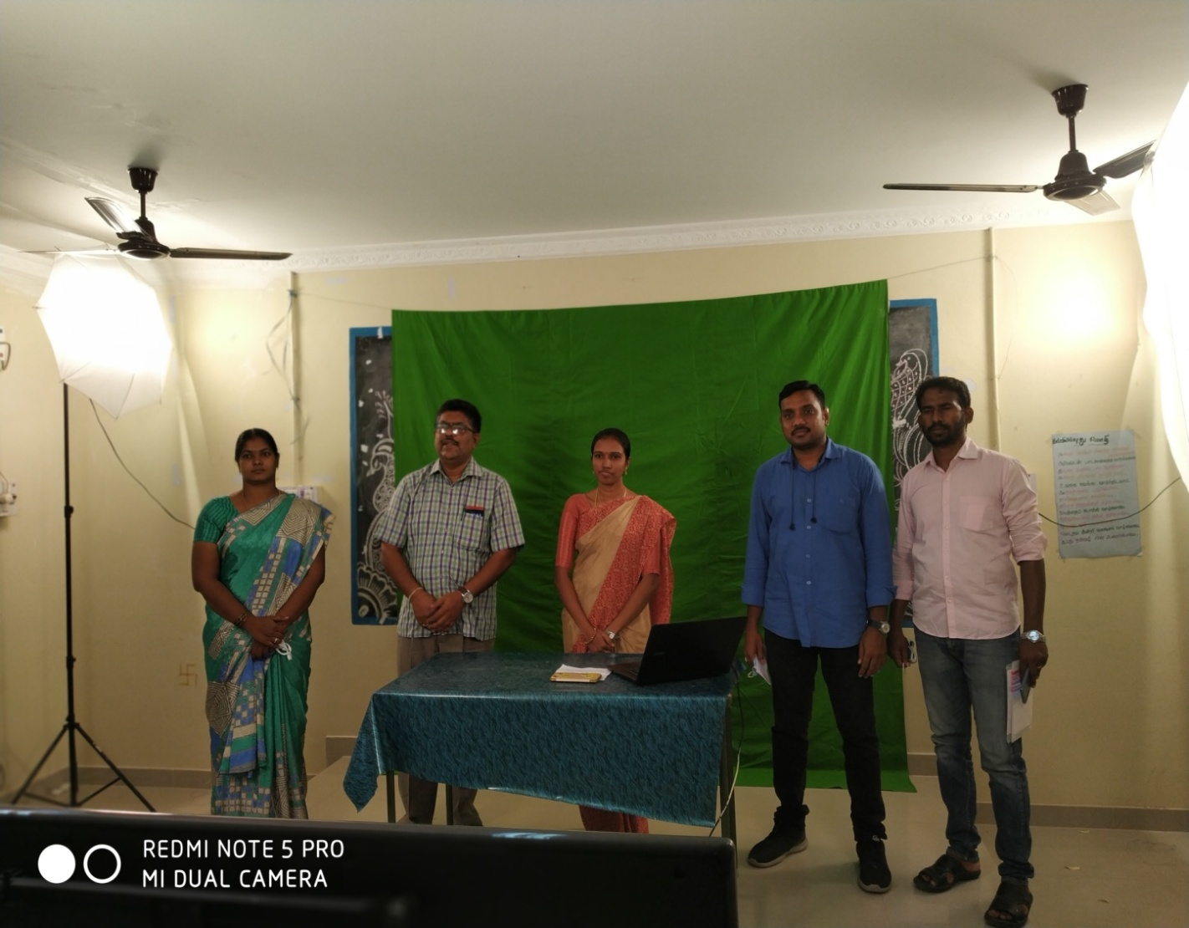

Competency frame work:
As per the guidance given by State Council of Educational Research and Training, the faculty members in DIET, Salem involved in the subject wise Competency framework in the month of April to June (work from home).
Sl no | Subject | Faculty members
1 | Tamil | M.JAYAMANI, Lecturer
2 | Tamil | K.KALAIVANAN, Lecturer
3 | English | B.ANANTHI, Lecturer
4 | English | S.SELVI, Lecturer
5 | Mathematics | Dr K.Kanaki, Senior Lecturer
6 | Mathematics | M.MAHALAKSHMI, Lecturer
7 | Mathematics | K.Kavitha, Lecturer
8 | Science | Dr P.Govinda Prakash
9 | Science | Dr S V VIJAYALAKMI SHANKAR, Senior Lecturer
10 | Science | Dr P. So.Kesavan
11 | Science | T.Prabhakaran, Lecturer
12 | Science | K.Rameshkumar, Lecturer
13 | Science | Dr E.Manvizhli, Lecturer
14 | Science | V.Suganya, Lecturer
15 | Science | Anbarasan, Lectuer
16 | Science | B.Udayakumar, Lecturer
17 | Social science | G.DHANAMMAL, Lecturer
18 | Social science | R.Ravi, Lecturer
Forty per cent content reduction work to 5th standard:
The following faculty members were involved in the 40% content reduction work in the month of May -2020.
Sl no | Subject | Faculty members
1 | Tamil | M.JAYAMANI, Lecturer
2 | Tamil | K.KALAIVANAN, Lecturer
3 | English | B.ANANTHI, Lecturer
4 | English | S.SELVI, Lecturer
5 | Mathematics | Dr K.Kanaki, Senior Lecturer
6 | Mathematics | M.MAHALAKSHMI, Lecturer
7 | Science | T.Prabhakaran, Lecturer
8 | Science | K.Rameshkumar, Lecturer
9 | Science | V.Suganya, Lecturer
10 | Social science | G.DHANAMMAL, Lecturer

Workbook preparation work:
As per the guidance given by State Council of Educational Research and Training, Chennai, the 15 faculty members in DIET, Salem involved in the subject wise work book preparation for 1st std to 10th std in the month of June to July2020.
Sl no | Subject | Faculty members
1 | Tamil | M.JAYAMANI, Lecturer
2 | Tamil | M.JAYAMANI, Lecturer
3 | English | B.ANANTHI, Lecturer
4 | English | B.ANANTHI, Lecturer
5 | Mathematics | Dr K.Kanaki, Senior Lecturer
6 | Mathematics | M.MAHALAKSHMI, Lecturer
7 | Mathematics | K.Kavitha, Lecturer
8 | Science | Dr P.Govinda Prakash
9 | Science | Dr S V VIJAYALAKMI SHANKAR, Senior Lecturer
10 | Science | Dr P. So.Kesavan
11 | Science | K.Rameshkumar, Lecturer
12 | Science | Dr E.Manvizhli, Lecturer
13 | Science | V.Suganya, Lecturer
14 | Science | B.Udayakumar, Lecturer
15 | Social science | G.DHANAMMAL, Lecturer
Dr M.Selvam, Principal, DIET, Uthamacholapuram
April 2020
- Collected the rules and regulations of vocational education for various sources from 07.04.2020 to 11.04.2020 (work from home).
- Coordinated with the 7 district’s DIET for the Bridge course work for 2nd to 8th standard from 20.04.2020 to 29.04.2020 (work from home).
May 2020
- Verified the scholarships particular of Ezhil TTI Kolathur at DIET on 05.05.202.
- Coordinated with faculty members for 40% of content reduction to 5th standard from 18.05.2020 to 27.05.2020 (work from home).
June 2020
- Involved in the 5th standard Bridge course shooting arrangements at BRC, Salem Rural on 08.06.2020.
- Involved in the preparation of Digital content shooting at DIET on 24.06.2020.

July 2020
- Participated in Principals review meeting by Zoom application, which was organized by SCERT on 08.07.2020, 09.07.2020,13.07.2020,15.07.2020, 19.07.2020 and 22.07.2020.
- Participated in the celebrations of “Kalvi valarchigal” at DIET on 15.07.2020.
August 2020
- Celebrated Independence Day at DIET on 15.08.2020

September 2020
- Participated in the video conferencing which was organized by SCERT at DIET on 01.09.2020, 05.09.2020 & 16.09.2020.
- Participated in the Dr Radhakrishnan award “ Nallachiriyar virudhu” at Collector ate on 07.09.2020
- National Builder Award is conferred to the Principal as well as Mr S.Manikandan , Lecturer by Rasipuram Rotatry Club on 09.09.2020.
- Visited Jayarani MHSS, Nethimedu regarding the selection of valuation camp on 09.09.2020.
- Participated in the Audio recording planning meeting at DIET on 15.09.2020.
- Inaugurated the workshop in Radio script for 11th and 12th Mathematics on 18.09.2020
- Visited D.EL.Ed., Examination 2020 centers GHSS, Neikarapatti & GBHSS Kondalampatti on 21, 22,23,26,28 &29.09.2020 .
In-service Field Interaction Innovation and Coordination Branch,
Dr P Govinda Prakash, Senior Lecturer,Mr K Ramesh Kumar Lecturer,
Dr. E. Maanhvizhi,, Lecturer,
Pleiothematic Lecture Series
& Tele Grooming Series
Covid-19 Pandemic situation has created an adverse situation for the continuing education of teachers, hence the members of DIET Ramesh Kumar Lecturer, Dr. E. Maanhvizhi,, Lecturer, Govinda Prakash, Senior Lecturer belonging to In-service Field Interaction and Co-ordination Branch of District Institute of Education and Training, Uthamacholapuram, Salem headed by Principal Dr. M. Selvam planned to conduct a series of programmes for the upliftment of the teacher’s knowledge, known as PleiothematicLecture Series programmes from 22.06.2020. Pleio means Many in Greek. Hence a variety of topics were taken up from wide range, Value based topics were planned for improving the moral development of the students, and students with special needs have been addressed with the topics like Learning Disability.
These programmes were conducted for the professional development of the teaching community through Google Meet on various topics. So far 7000 teaching community people from different levels of teaching profession like Secondary grade, Graduate teachers, post graduate teachers, college professors, university professors, personals from NGO who are involved in the education related activities were also part of the programme. Teacher Trainees of different levels like B.Ed., M.Ed., research scholars from various departments have been benefited out of this lecture series. The participants are from different states of the country like Jammu and Kashmir, Punjab, Bihar, West Bengal, Assam, Maharashtra, Telangana, Uttar Pradesh, Arunachal Pradesh and from different parts of the world like Saudi Arabia, Bhutan, Nepal, Pakistan, Philippines, Syria, Camaroon and so on.
Pleiothematic Lecture No | Title of the Webinars Organised | Name of the Experts | Date | Total beneficiaries
 |  |  |  | From TamilNadu | Outside TN | Outside India | Total
01 | Gamification of English Language Teaching | Dr Kamala Devi,  Assistant Professor,  Sri Sarada College of Education,  Salem. | 22.06.20 | 184 | 56 | 10 | 250
02 | Technology Enabled Teaching Learning | Dr K. Biju,  Assistant Professor,  Central University,  Thiruvarur. | 24.06. 20  Time: 11 am– 12.00 pm | 185 | 60 | 15 | 250
03 | Remote Learning | B. Oliver,  Sate Head,  Pratham Foundation,  Tamil Nadu. | 26.06.2020Time: 11 am– 12.00 pm | 174 | 62 | 14 | 250
04 | Nearpod for Interactive Teaching | K. Iyappan,  BRTE,  BRC kadayampatti | Date : 29.06.2020  Time: 11 am– 12.00 pm | 174 | 62 | 14 | 250
05 | Internet Addiction | Dr C. Babu,  Clinical Psychiatrist,  Sri Gokulam Hospital,  Salem | 07.07.2020Time: 3.00pm – 4.00pm | 155 | 80 | 15 | 250
06 | Learning Disability | Mrs. Elizabeth Suresh,  Principal,  Rashmika and Raksha Educational Trust, Coimbatore | 11.7.2020Time: 11.00am – 12.00pm | 152 | 83 | 15 | 250
07 | Teacher’s role in Moral Development | M. VinodhaRajam,  Inspirational and speaker,  Viruthunagar | 14.7.2020 03.00pm – 04.00pm | 192 | 42 | 16 | 250
08 | Child Rights and Child-friendly education | CHRISTU RAJ,  UNICEF-CRY District Coordinator, Salem.  (Advocate, High Court of Judicature at Madras) | 17.7.2020 02.00pm – 03.00pm | 189 | 48 | 13 | 250
09 | Developmental Psychology and Learning | Manikandan.S  M.Sc.(Zoo), M.Sc.(Psy), M.Ed., M.Phil.,  Lecturer, ET Branch, DIET-Salem  (Trainer/ Motivational Speaker) | 21.7.202002.00pm – 03.00pm | 212 | 30 | 08 | 250
10 | Perspectives of Research Writing and Publication | Dr S.Prabu Shankar  Assistant Professor & Head of the Department,  Department of Education,  Institute of Advanced Study in Education (Autonomous),  Saidapet, Chennai – 600 015 | 24.7.202011.00am – 12.00pm | 176 | 43 | 31 | 250
11 | Thavar indri Tamil Yeludha | Dr. U. Prabakaran,  Former Professor& Head,  Tamil University,  Thanjaur – 613 010 | 28.7.2020 11.00 am – 12.30 pm | 196 | 46 | 8 | 250
12 | Reaching the Unreached | Saif Mohammed,  State Resource Consultant,  Our Responsibility to Children Programme,  Kerala. | 04.8.2020 11.00am – 12.30pm | 184 | 49 | 17 | 250
13 | Progressive Conditions for Reframing the Inclusive Education. | Dr. V. Sebasthian,  Congregation of Don Bosco,  Rome | 11.8.2020 11.00am – 12.30pm | 183 | 49 | 18 | 250
14 | Story Telling | J.Inbaraj,  M.A., M.Ed., M.Phil., DEPA.,  Reader (Rtd.,),  SCERT, Chennai. | 18.8.2020  03.00pm – 04.30pm | 183 | 41 | 26 | 250
15 | Techniques to Improve Your Communicative English | Dr N. Sangeetha,  Vice Principal,  Kailash Women’s College,  Nangavalli, Salem | 25.8.202011.00am – 12.30pm | 185 | 59 | 6 | 250
16 | Valvai valamakum kadaigal | K. Hari Anandh,  Head Master,  PUPS, Eacha Odai Puthur,  Attur Block, Salem District. | 01.9.2020 Time: 11.00 am – 12.30 pm | 213 | 32 | 05 | 250
17 | Child Rights education for Teachers. | Henri Tiphagne,  Executive Director,  People’s Watch,  A National Human Rights Organization | 12.9.2020 Time: 11.00 am – 12.00 pm | 176 | 59 | 15 | 250
18 | Healing: Magic power of Medical Plants | Dr. S. D. K Shri Devi,  Assistant Professor  Department of Botany,  Sri Sarada College for Women (Autonomous),  Salem 16. | 15.9.2020 Time: 11.00 am – 12.30 pm | 176 | 59 | 15 | 250
19. | Motivational Skills for Teachers | G. SaravanaPerumal,  Managing Director,  CONFIDO Training Solutions,  Salem | 22.9.2020 Time: 11.00 am – 12.30 pm | 178 | 52 | 20 | 250
20. | Time Management | MrR.Rajendran, B.E.,  Deputy Director/ Principal,  Government Industrial Training Institute,  Semmandalam, Cuddalore. | 29.9.2020 Time: 11.30 am – 01.00 pm | 179 | 75 | 06 | 250

2. PRE SERVICE TEACHER EDUCATION BRANCH
Video Lesson- Resources prepared and utilized for D.El.Ed Students during Covid-19 lockdown Period
(Volunteers Programme)

 | Subject | Subject coordinator | Name of the presenter | No of videos produced
 | Indian Education System | Dr.P.Govinda Prakash,  Senior Lecturer,  DIET, Uthamacholapuram,  Salem-636010 | A.Vimala , Jr. Lecturer  St. Joseph TTI, Pagalpatty, Salem-636304. | 02
 | Facilitating and Enhancing Learning-II |  | Mrs. S. Rajam Arul Selvi, B.T.Asst. Mathematics,  C.S.I. Teacher Training Institute, Salem – 636007 | 05
 | Teaching of Tamil -II | Mrs. M.Jayamani,  Lecturer, DIET, Uthamacholapuram,  Salem-636010 | Mrs. M.Jayamani,  Lecturer,  DIET, Uthamacholapuram, Salem-636010 | 10
 | Teaching of Tamil -II |  | Mrs. Malarvizhi,  Lecturer, St. JosephTTI, Pagalpatty, Salem-636304 | 01
 | Teaching of Tamil -II |  | Mrs.V. Victy Selva Kumari,  Junior Lecturer,C.S.I. Teacher Training Institute,  Salem 636007 | 09
 | Teaching of English-II | Mrs. S.Selvi,  Lecturer, DIET, Uthamacholapuram,  Salem-636010  ` | Mrs. S.Selvi, Lecturer,  DIET, Uthamacholapuram, Salem | 01
 | Teaching of English-II |  | Mrs. J. Grace Priya,  B.T. Asst. English  C.S.I. Teacher Training Institute for Women, Salem | 13
 | Teaching of English-II |  | Mr.R.Sridhar  Junior Lecturer  Government Teacher Training Institute, Gangavalli | 02
 | Teaching of English-II |  | N.Visalatchi, Junior Lecturer,  Government Teacher Training Institute,  Gangavalli, Salem-Dt. | 06
 | Teaching of English-II |  | S.Jona Maria Selvi, Lecturer, St. Joseph Teacher Training Institute, Pagalpatty, Salem-636304 | 02
 | Teaching of Mathematics-II | Mrs. M.Mahalakshmi,  Lecturer, DIET, Uthamacholapuram,  Salem-636010 | Mrs. M.Mahalakshmi,  Lecturer,  DIET, Uthamacholapuram, Salem-636010 | 05
 | Teaching of Mathematics-II |  | Mrs. R.Kavitha,  Lecturer,  DIET, Uthamacholapuram, Salem-636010 | 01
 | Teaching of Mathematics-II |  | S. Jona Maria Selvi , Mathematics Lecturer , St. Joseph TTI, Pagalpatty, Salem-636304 | 03
 | Teaching of Science-I &II | Mrs.V.Suganya  Lecturer, DIET, Uthamacholapuram,  Salem-636010 | Dr.P.Govinda Prakash,  Senior Lecturer,  DIET, Uthamacholapuram,  Salem-636010 | 02
 | Teaching of Science-I &II |  | Mrs.V.Suganya  Lecturer, DIET, Uthamacholapuram,  Salem-636010 | 03
 | Teaching of Science-I &II |  | B.Uthayakumar  Lecturer, DIET, Uthamacholapuram,  Salem-636010 | 02
 | Teaching of Science-I &II |  | E.Siva Peruman .  Junior Lecturer  Government Teacher Training Institute Gangavalli, | 07
 | Teaching of Science-I &II |  | D.S. Arul Selvi. St. Joseph Teacher Training Institute, Pagalpatty, Salem-636304 | 04
 | Teaching of Social Science-II | Mr.R.Ravi,  Lecturer, DIET, Uthamacholapuram,  Salem-636010 | Mr. R.Ravi, Lecturer,  DIET, Uthamacholapuram, Salem-636010 | 01
 | Teaching of Social Science-II | Mr.R.Ravi,  Lecturer, DIET, Uthamacholapuram,  Salem-636010 | Mrs.V. Victy Selva Kumari,  Junior Lecturer ,  C.S.I. Teacher Training Institute, Salem – 7 | 02
 | Teaching of Social Science-II | Mr.R.Ravi,  Lecturer, DIET, Uthamacholapuram,  Salem-636010 | Mrs. Malarvizhi , Lecturer,  St. JosephTTI,  Pagalpatty, Salem-636304 | 01
Over all 82 videos produced for D.El.Ed., students |  |  |  | 82

Dr S.Peter Anand, Lecturer, PSTE Branch
April 2020 and May 2020
- Text book and worksheet preparation for Physical education and yoga.
June 2020
- Text book and worksheet preparation for Physical education and yoga. Social science bridge course material translations work.
July-2020
- 1.07.2020 to 14.07.2020- Physical education text book correction and Expert work.
- 17.07.2020 to 31.07.2020- Ethics and Indian culture video lesson preparation, shooting.
August
- Yoga book video shoot editing work.
- Yoga- school book review work.
- X standard physical education text book work.

Branch work

- 3.08.2020 to 7.08.2020 –attended CCRT online training Dr S.Peteranand and Mrs S.Selvi.
- Nominal roll verification for Govt, Aided and private TTI students by
Dr P.Govindaprakash and Mrs S.Selvi.
September
- 9 AM to 10 AM- exam centre student monitoring work Dr P.Govindaprakash ,V.Suganya, M.Jayamani, R.Ravi .
- 1.09.2020 to 15.09.2020-Text book and worksheet preparation for Physical education and yoga Dr S.Peteranand.

3. EDUCATIONAL TECHNOLOGY BRANCH
Mrs. G DHANAMMAL, Senior Lecturer.
Mr S MANIKANDAN, Lecturer. Mrs.R.KAVITHA, Lecturer
Booster Aid
S.No | Date of launch | Title | Name of the Developer
1. | 16.07.2020. | Booster Aid in Class room Science - A digital Self-Learning content | Dr M. Selvam, Principal,  DIET, Uthamacholapuram, Salem-10
2. | 20.08.2020 | Concept Master in components of knowledge-A Digital Self-Learning Content (Tamil) | Dr M. Selvam, Principal,  DIET, Uthamacholapuram, Salem-10
Webinar

S.No | Date | Webinar Topic | Name of the Expert | No of Beneficiaries
1 | 07/06/2021 | Design thinking | Dr.R.NAGALAKSHMI,SENIOR LECTURER,CMDE | 189
2. |  | A view of World Education | K.Kalaivanan (Lecturer) | 94

Preparation of Digital Video Lesson Content
As per guidance of SCERT, the DIET Uthamacholapuram have sincerely involved in preparation of digital video lessons for BASIC ELECTRONICS ENGINEERING and for class XI and XII. As per the guidance given by SCERT the prioritised topics were selected by the faculty members of DIET to make digital video lessons for class II to IX for all subjects. DIET, Uthamacholapuram have prepared the video lessons in Tamil for History subject, class VI.
S.No | Subject | No of videos prepared
1. | BASIC ELECTRONICS ENGINEERING for class XI and XII | XI- 34  XII-42
2. | TEXTILE AND DRESS DESIGNING | XI-42  XII-38
3. | DIGITAL VIDEO LESSON CONTENT FOR CLASS VI IN TAMIL-PROSE | 09
4. | DIGITAL VIDEO LESSON CONTENT FOR CLASS VI IN HISTORY (Tamil Medium) | 12
5 | PREPARATION OF DIGITAL VIDEO LESSON CONTENT FOR CLASS VI IN HISTORY (English Medium) | 10
6. | PREPARATION OF DIGITAL VIDEO LESSON CONTENT FOR CLASS XI AND XII – COMPUTER SCIENCE – (ENGLISH MEDIUM) | 08
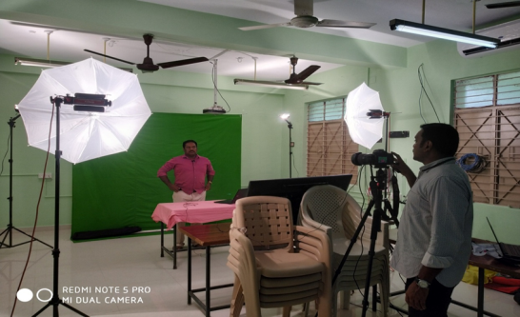 | 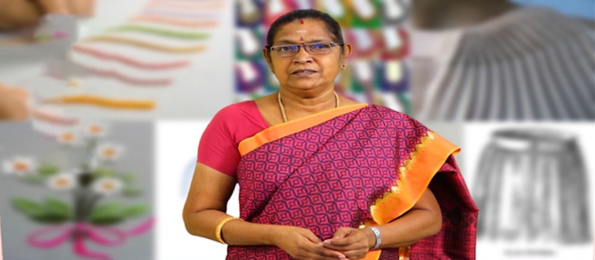
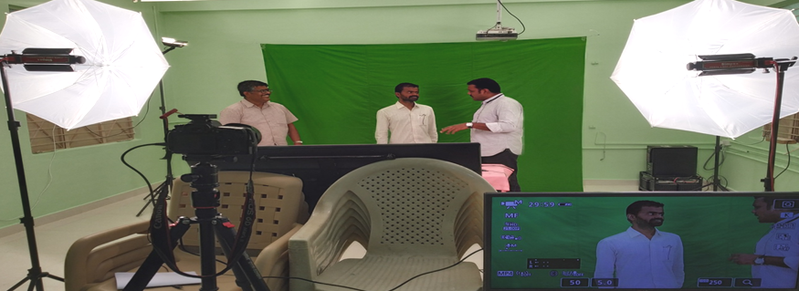 | 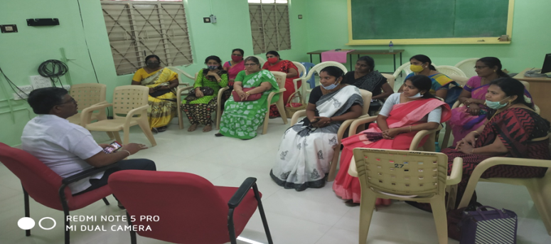
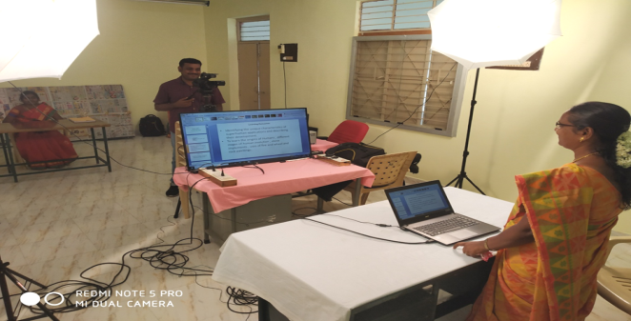 | 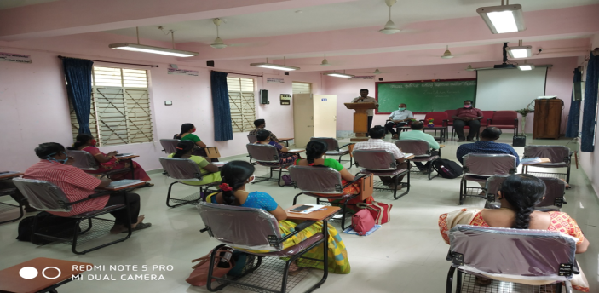
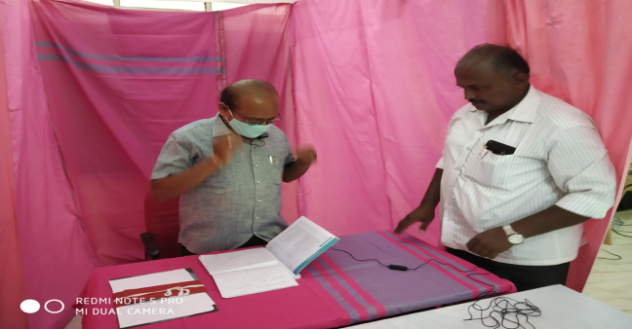

WORK EXPERIENCE BRANCH
Dr S V VIJAYALAKMI SHANKAR, Senior Lecturer, Mr C ANBARASAN, Lecturer, Mr K KALAIVANAN, Lecturer,
Dr S V VIJAYALAKMI SHANKAR, Senior Lecturer conducted webinar on online programme on ICT for Tharamangalam teachers from 08.05.2020 to 31.05.2020 via Zoom
s.No | Date | Webinar Topic | Name of the Expert | No of Beneficiaries
01 | 8.5.2020 from10.30 am to 12.30 pm | Online Programme on ICT –Basic ICT Tools and ICT Atmosphere in classroom | Mr.G.Anandha Kannan, Kallakuruchi | 90 teachers
02 | 9.5.2020 from10.30 am to 12.30 pm | Online Programme on ICT –a guide to MS WORD | Mr.Vijayakumar, Kallakuruchi | 96
03 | 11.5.2020 from10.30 am to 12.30 pm | .Online Programme on ICT –Cybercrime & Cyber Safety | MrVijay Ananth | 84
04 | 12.5.2020 from10.30 am to 12.30 pm | Online Programme on ICT –PPT Basic Presentation & Simple Animation-1 | Mr.SakthivelMurugan | 90
05 | 12.5.2020 from10.30 am to 12.30 pm | Online Programme on ICT –Creation of animation using PPT-2 | Mr Thangaraj,SGT,PIES,  Parappatti,salem dt | 85
06 | 14.5.2020 from10.30 am to 12.30 pm | Online Programme on ICT –Mind Map | Mr.Janakiraman, BT Asst, PUMS, Mattayampatti,Tharamangalam Block salem dt | 87
07 | 15.5.2020 at 10.30 am to 12.30 pm | Online Programme on ICT -Google Products / Google Forms | MrVijay Ananth, BT Asst, PUMS, AP Vattam, Tharamangalam Block Salem dt | 89
08 | 16.5.2020 from 10.30 am to 12.30 pm | Online Programme on ICT -Power Presentation Part -3 | Mr.Prabhagaran,SGT,PUES,Pallikondanparai,Tharamangalamblock,Salem Dt | 91
09 | 18.5.2020 from 10.30 am to 12.30 pm | Online Programme on ICT -Useful Apps | Mr.Vijay Ananth, BT Asst, PUMS, AP Vattam, Tharamangalam Block salem dt | 91
10 | 18.5.2020 from 10.30 am to 12.30 pm | Online Programme on ICT -Foss Introduction and relative tools | Mr.GuruBT Asst, PUMS, Adimalaipatty, Pnamarathuaptty, Salem | 92
11 | 20.5.2020 from 10.30 am to 12.30 pm | Online Programme on ICT -Sessions on LMS Platform | Mr.Satheesh, Teacher,SSA,Chennai | 92
12 | 21.5.2020 from 10.30 am to 12.30 pm | Online Programme on ICT -How to Contribute to TNTP | Mr.Satheesh, Teacher,SSA,Chennai | 86
13 | 22.5.2020 from 10.30 am to 12.30 pm | Online Programme on ICT -Basics in Computer/Wikipedia | Mr.Vijay Ananth, BT Asst, PUMS, AP Vattam, Tharamangalam Block salem dt | 92
14 | 25.5.2020 from 10.30 am to 12.30 pm | Online Programme on ICT -Paint 3D | Mr.Prabhagaran,SGT,PUES,Pallikondanparai,Tharamangalamblock,Salem Dt | 80
15 | 27.5.2020 from 10.30 am to 12.30 pm | Online Programme on ICT -Video Editing | Mr.Vijay Ananth, BT Asst, PUMS, AP Vattam, Tharamangalam Block Salem dt | 90
16 | 04.6.2020 from 10.30 am to 12.30 pm | Online Programme on ICT –MS EXCEL | Dr.S V Vijayalakmishankar | 87

CURRICULAM MATERIAL DEVELOPMENT AND EVALUATION BRANCH
Dr R NAGALAKSHMI ,Senior Lecturer,Mrs B ANANDHI,Lecturer
s.No | Date | Webinar Topic | Name of the Expert | No of Beneficiaries
01 | 10/09/2021 | “Questioning techniques-a skill to enhance” | Dr.R.NAGALAKSHMI,SENIOR LECTURER,CMDE | 276 (Kadayampatti & Omalur Block Teachers)

Chief Editor : Dr M SELVAM, PRINCIPAL, DIET, UTHAMACHOLAPURAM, SALEM-636010

Associate Editors : Dr P GOVINDAPRAKASH (SL) , Mrs V SUGANYA (L) ,
Editor : Mrs S.Selvi (L)

This Newsletter is Prepared and Published by PSTE Branch Branch
Phone: 0427-2273751 e-mail : dietslm@tn.nic.in
Visit : www.dietsalem.in , Visit: salemdieteducationalchannel

